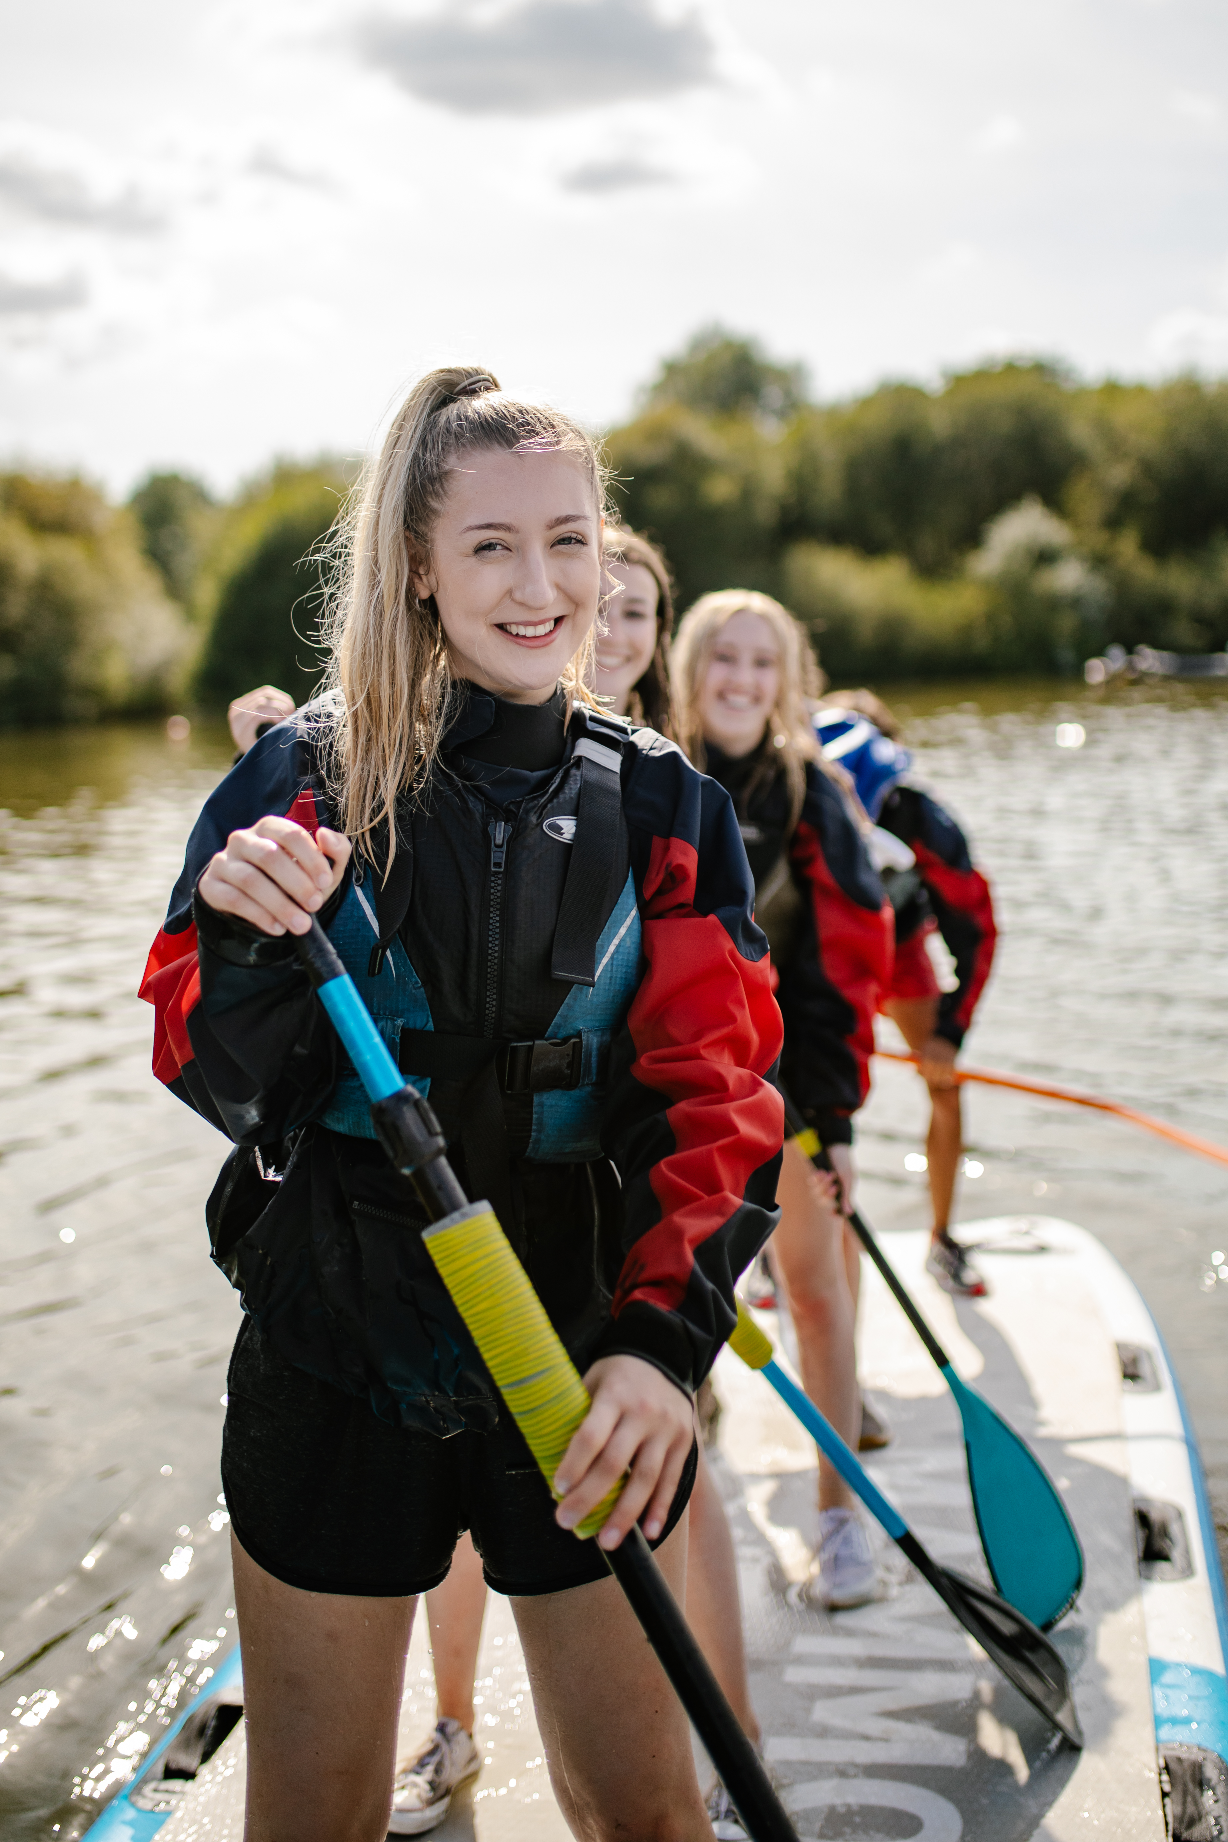
April 2023
Seasonal
Outdoor Education Instructor
Job Description & Person Specification
| Key Information

Job Title: Seasonal Outdoor Education Instructor

Accountable to: Chief Instructors

Location: Hindleap Warren Outdoor Centre, Wych Cross, East Sussex, RH18 5JH.

Contract Length: Summer seasonal position (With possibility of ongoing, permanent work)

Salary: £23,805 per annum, (£1,983 gross salary, per month) Plus pay progression based on qualifications and number of sessions you can lead.

Hours: 42 hours per week on average. (Some evenings & overnight work as required as well as during some weekends) – timetabled well in advance.

Eligibility: Must be 18 years old or over, with a right to work in the UK. You will be required to complete an enhanced DBS application.

| Additional Benefits Include

- Summer staff training to Devon in August at the centre’s expense. Focusing on working towards the next level of qualifications on Rock climbing, River Paddling and Mountain Biking.

- Generous holiday allowance – 40 days A/L per annum.

- We will support you in working towards industry qualifications and your ongoing professional development.

- Shared accommodation is available on site at a charge, variable in line with the Government’s set NMW accommodation offset rate.

- Catered meals provided while working, when the kitchen is serving young people in residence.

- Access to Employee Assistance Programme and Healthcare Plan.

| The Outdoor Education Instructor Role

We are committed to providing a top-quality experience to our visitors and all staff play an active part in achieving that aim.

The instructional staff are led by a highly qualified, experienced and approachable management team.

It is the overall quality of our staff and consequently the quality of our provision that allows us to retain a very high reputation.

| Role Description – Main Duties & Tasks

| Instructional work with clients
- Deliver activity sessions where trained and competent.
- To operate all activities according to Centre Operating Procedures and appropriate National Governing Body qualifications.
- To be a good role model.
- Committed to the delivery of key session outcomes.

| Activity equipment maintenance
- Once trained - maintain activity equipment in good order, complying with Centre policy and best practice within the industry.

| Duty Instructor Role
- Supervise residential groups in the performance of mealtime cleaning duties.
- Run the tuck shop in the evenings and as required.
- Maintain an overnight on-site presence (special accommodation provided) to be available to help residential groups with any problems concerning their visit as well as providing first aid and emergency assistance to residential groups. The Duty Instructor is closely supported by the Duty Manager, who is a senior member of staff on call to give advice and assistance.
- Some cleaning duties.

| Person Specification

| Essential Experience, Knowledge & Skills
- Previous experience and continued motivation for working with young people.
- An understanding of the importance of quality customer service and experience.
- An understanding of the value of outdoor education.
- The ability to communicate with a wide client base.
- Ability to identify boundaries in relationships with clients.

| Essential Personal Attributes
- Collaborative team player, strong communicator, and a willingness to work effectively with others.
- Able to work independently, demonstrating proactivity and initiative.
- Good work ethic with a practical and dynamic approach to work.
- A composed demeanour, able to keep calm under pressure and solve problems when they arise, efficiently and effectively.
- Absolute commitment to the principles of equality, diversity and inclusion.

| Desirable Experience, Knowledge & Skills
- Environmental session awareness.
- Awareness of current best practices in safeguarding.
- Basic computer skills.
- Previous experience of working in outdoor centres.
- Experience of working with a range of different young people with different backgrounds and needs.
- Awareness of the issues of living and working together or previous experience of sharing living space with others.

| Desirable Qualifications

- First Aid Qualification
- Archery Qualification
- Paddlesport Qualification (E.g. Paddlesport Instructor or higher)
- Climbing Qualification (E.g. Climbing Wall Instructor or higher)
- Walking Qualification (E.g. Lowland Leader or higher)
- Minibus license

| How to Apply

London Youth embraces equality, diversity, and inclusion. We are committed to the ongoing development of an organisation that values and represents a variety of backgrounds, perspectives and skills and welcome applications that reflect this.

Read the full Job Description & Person Specification that outlines the expectations of this role in detail. If this sounds like you, please apply.

To apply, submit all the following via email to recruitment@londonyouth.org with the subject line Seasonal Outdoor education Instructor Application – Hindleap Warren:

- Your comprehensive CV
- A supporting statement indicating how your experience meets the requirements of the Person Specification
- Declaration of criminal convictions
- Equal Opportunities monitoring form

If you would like to ask any questions about the role or process feel free to ring 01342 822625 and ask for Tom Fox or Graham Smith.


Hindleap Lane, Wych Cross, RH18 5JH
www.hindleapwarren.org
@HindleapWarren
@HindleapWarren

